1. We can customize the way that objects are displayed in the variable sections during debugging.
2. 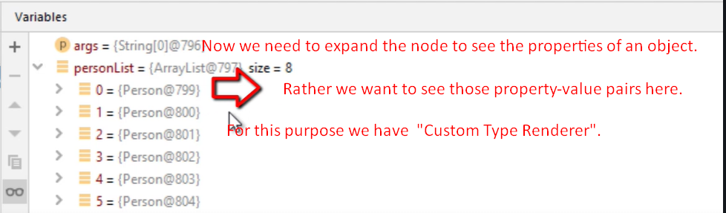
3. 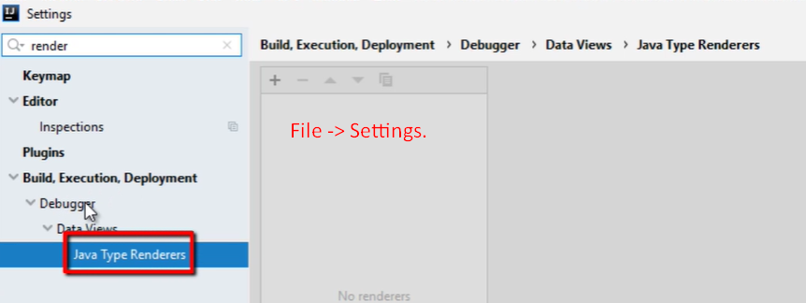
4. 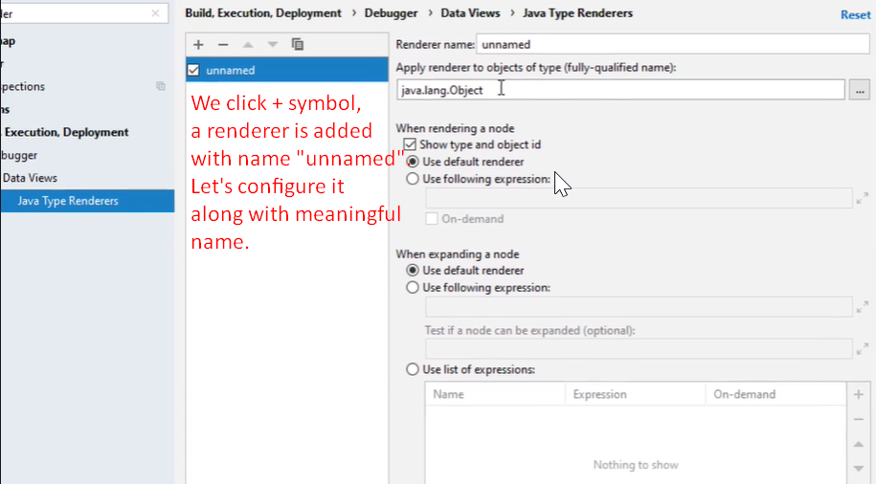
5. 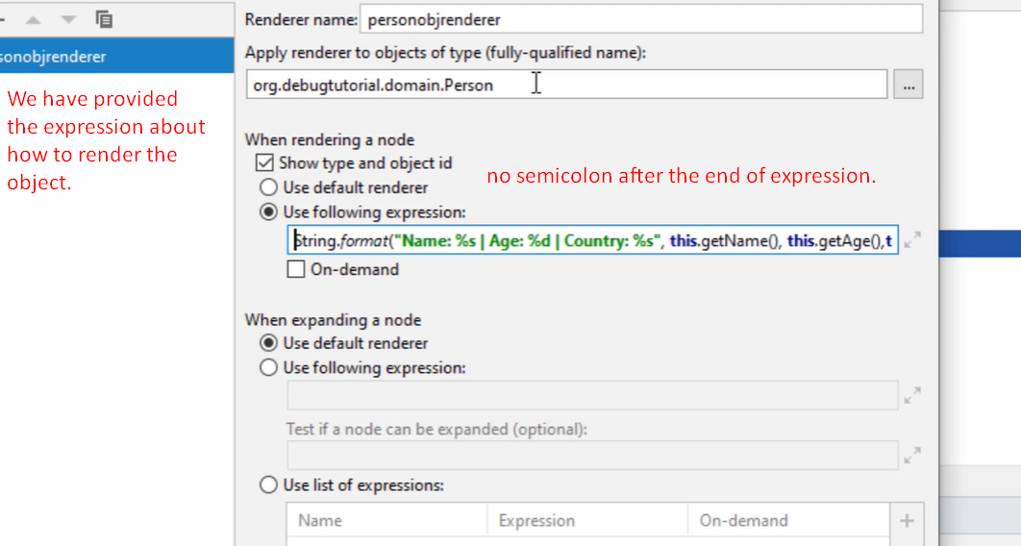
6. 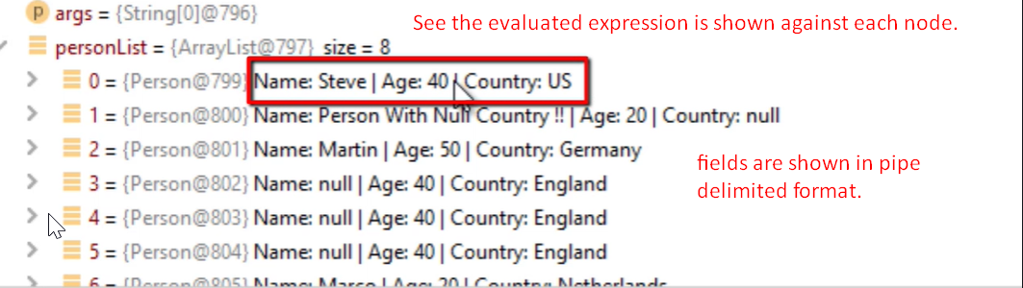
7. Type renderer can slow down the performance but we can do something in renderer configuration.
8. 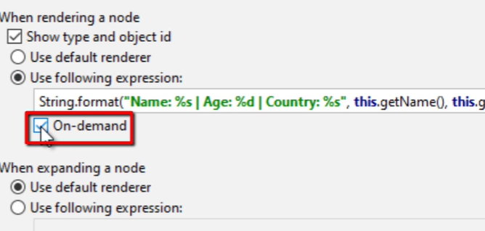
9. 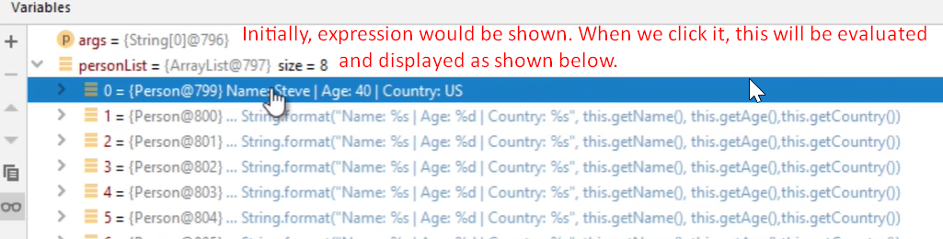
10. 